

Exercise: Basic Linux & Bash commands

================================================================================ ==============================================
On Hyper-V/Oracle/VMware (whatever your preferred Linux workaround is currently) download Ubuntu image and install it as a virtual machine or WSL2. After this is done:

- Create a file friends.txt with a list of names of three of your friends on separate lines.
- Display the contents of friends.txt on the console.

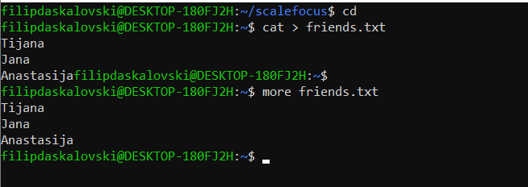
- Rename file friends.txt to bestfriends.txt

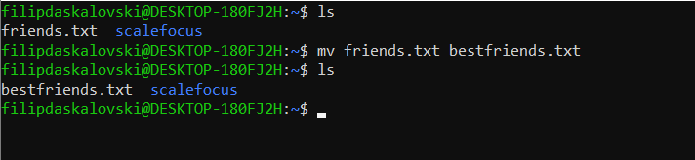
- Make a copy of bestfriends.txt under the name sysadmins.txt

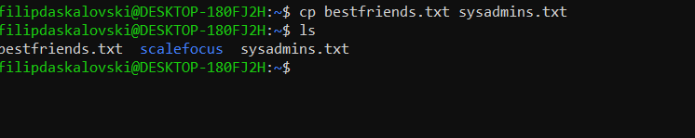
- List all files whose name begins with letter 'b' and ends with extension txt.
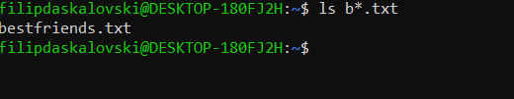

- Write a command that will tell you how many bytes are taken up by file sysadmins.txt

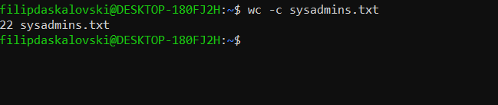
- Create file cars.txt with a list of 5 brands of cars on separate lines.

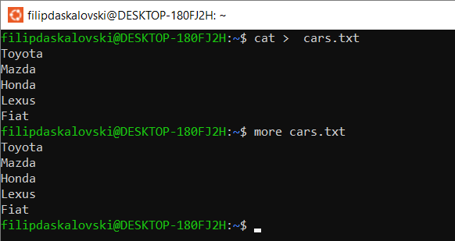
- Check how many bytes are taken up by the file.
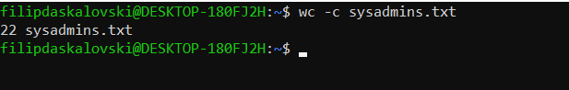

- Copy the file cars.txt into directory /tmp
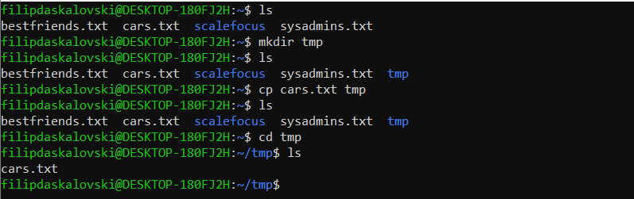

- List all files with extension *.txt in directory /tmp and verify that the file was copied properly.
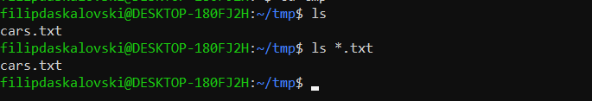
- Without leaving your home directory rename file cars.txt located in /tmp to vehicles.txt in /tmp
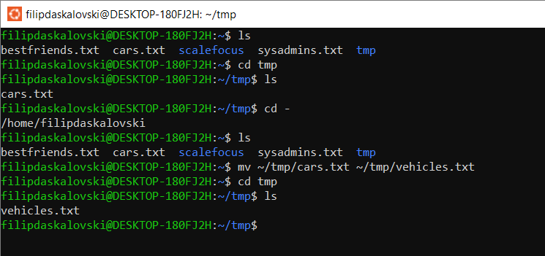
- Display the contents of /etc/passwd file on the screen interactively (so you can search, scroll up and down)
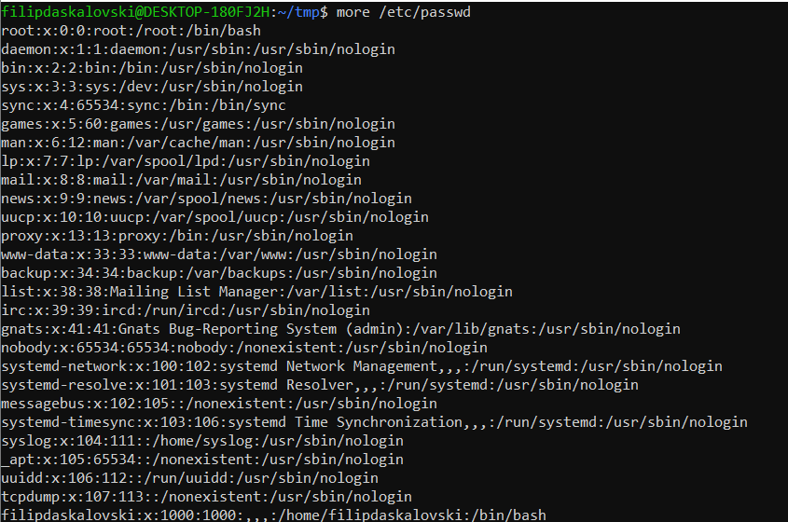

69 Bulgaria Blvd., Infinity Tower B, fl. 8, Triaditza district, 1404 Sofia, Bulgaria | +359 2424 6484 | sales@scalefocus.com | www.scalefocus.com

